Utility Meter Field Verification
UX Mockups and Interaction Specification
Document owner | Version | Date | Status
Michael Yaacoub, Sr Solution Engineer | 1.0 | 2026-08-24 | Draft

This template follows the sample UX pack: each SCR screen pairs a visual mockup with a specification panel, and the pack closes with a navigation-flow map.

1. Experience Overview
The primary user is a field technician standing at a meter, often in a dark cupboard or a basement, wearing gloves, with no signal and sometimes a customer watching. A revenue analyst works the resulting record from a desk. Design principles: the procedure states what evidence it needs before the technician takes the photograph, not after; nothing about a tamper case can be submitted incomplete; the customer's account detail on the device is limited to what the job requires; and no evidence is ever lost to a dead spot.
Persona | Primary goal | Device / viewport | Usage context
Field technician | Verify the meter completely at the first visit and capture evidence that will hold up later | Field handheld, 6 inch | Meter cupboards, basements and rural sites, gloved, dark or bright, no signal
Revenue analyst | Turn a verification into a correct, approved billing adjustment | Web, 1440 pixels and wider | Revenue office, working many verifications at once

2. Screen Inventory
Screen ID | Screen name | Mapped feature | User goal | Primary action
SCR-01 | Verification Round | FEAT-01 | Plan the round and arrive prepared | Start the job
SCR-02 | Guided Meter Verification | FEAT-02 | Capture everything the record will need | Submit the verification
SCR-03 | Tamper Evidence and Custody | FEAT-03 | Build a case that survives challenge | Submit the tamper case
SCR-04 | Adjustment and Approval | FEAT-04 | Correct the bill from the evidence | Approve the adjustment

3. Screen Mockups and Specifications

3.1 SCR-01 Verification Round
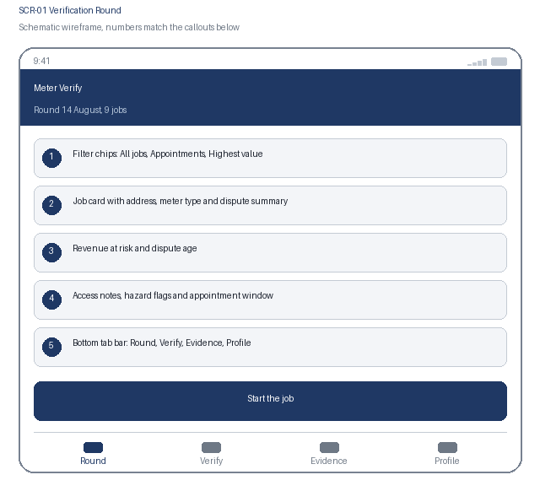  1. Filter chips: All jobs, Appointments, Highest value  2. Job card with address, meter type and dispute summary  3. Revenue at risk and dispute age  4. Access notes, hazard flags and appointment window  5. Bottom tab bar: Round, Verify, Evidence, Profile | Specification panel  Purpose: The technician sees the round ordered by exposure and reads the access and safety notes before travelling to a site.  Primary action: Start the job, which opens the verification procedure for that meter.  Data: Address, meter identifier and type, dispute summary and age, estimated revenue at risk, access notes, hazard flags, appointment window. Source: verification service. Customer payment and debt data are excluded from this payload.  States: Loading, scheduled, appointment required, hazard flagged, in progress, offline  Roles: Technician sees their own round; the dispatcher sees all rounds; analyst reads  Requirements: US-101, US-102, NFR-001, NFR-004

3.2 SCR-01 Interaction Details
Element / callout | Behavior | Validation | Accessibility
1. Filter chip | Filters the round in place and keeps scroll position; one chip active at a time | An empty result names the active filter | Radio buttons in a labelled group with the selected state announced
2. Job card | Opens the job detail with access and hazard information first | None | One link whose accessible name combines address, meter type and dispute age
3. Hazard flag | Expands to show the recorded hazard and any control required | A job with an unacknowledged hazard cannot be started | The hazard is announced assertively on opening the job, never conveyed by an icon alone
4. Start the job | Begins the verification and records the arrival time and location | Blocked where an appointment is required and none exists, with the reason stated | The block explains what is missing rather than presenting a disabled control

3.3 SCR-02 Guided Meter Verification
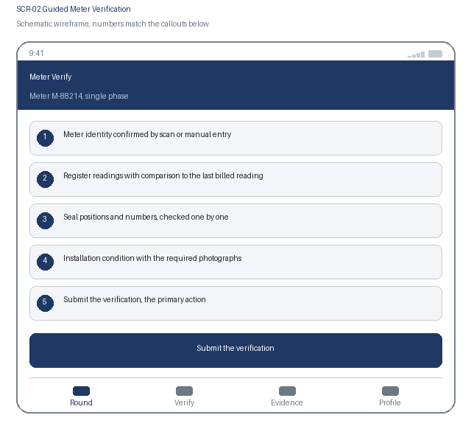  1. Meter identity confirmed by scan or manual entry  2. Register readings with comparison to the last billed reading  3. Seal positions and numbers, checked one by one  4. Installation condition with the required photographs  5. Submit the verification, the primary action | Specification panel  Purpose: The technician works the procedure for this meter type, capturing readings, seals and condition with the evidence each step requires.  Primary action: Submit the verification, which locks the record and evaluates the reading discrepancy.  Data: Meter identifier and type, register readings and last billed comparison, seal positions and numbers, condition assessment, photographs, capture location and time. Source: verification service over the metering cache.  States: Meter confirmed, in progress, implausible reading requiring confirmation, queued offline, submitted, discrepancy found  Roles: Technician captures; analyst reads; nobody edits a submitted verification  Requirements: US-201, US-202, NFR-003, NFR-005, NFR-006

3.4 SCR-02 Interaction Details
Element / callout | Behavior | Validation | Accessibility
1. Meter scan | Confirms meter identity and loads the matching procedure | A meter that does not match the job requires confirmation and records the discrepancy | Manual entry always available; confirmation announced with the meter identifier
2. Register reading | Numeric entry compared against the last billed reading as it is committed | A reading below the last billed value, or implying implausible consumption, requires a confirmation and a note | The comparison result is announced as text stating plausible or implausible, never colour alone
3. Seal check | Each seal position is checked in turn with its number recorded | A broken or missing seal is mandatory to record and routes the job to the tamper evidence path | Each position carries its location as the accessible name so positions are never confused
4. Condition photograph | Captures the required photograph for each evidential step | The step cannot be completed without its photograph, and the requirement is stated before the capture button | The requirement is announced before capture rather than as an error after it

3.5 SCR-03 Tamper Evidence and Custody
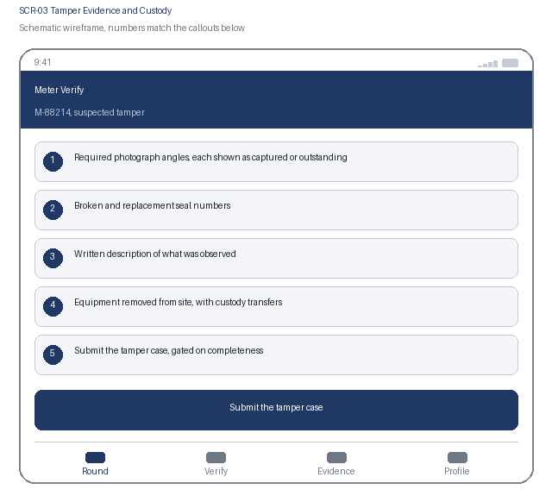  1. Required photograph angles, each shown as captured or outstanding  2. Broken and replacement seal numbers  3. Written description of what was observed  4. Equipment removed from site, with custody transfers  5. Submit the tamper case, gated on completeness | Specification panel  Purpose: Where tampering is suspected, the technician captures the full evidence set and starts the custody chain for anything removed.  Primary action: Submit the tamper case, which locks the evidence and notifies revenue assurance.  Data: Required angle list with capture state, broken and replacement seal numbers, written description, removed equipment with identifiers, custody transfers with both parties, time and location. Source: verification service.  States: Evidence outstanding, evidence complete, custody open, custody gap flagged, submitted, locked  Roles: Technician captures; evidence custodian receives; revenue assurance manager reviews  Requirements: US-301, US-302, NFR-004, NFR-006

3.6 SCR-03 Interaction Details
Element / callout | Behavior | Validation | Accessibility
1. Angle checklist | Lists every required photograph angle with its capture state | The case cannot be submitted while any angle is outstanding, and each missing angle is named | Outstanding angles are listed as text; capture state is stated per item rather than as a count alone
2. Seal number entry | Records the broken seal and the replacement fitted | Both numbers are mandatory; a replacement number outside the technician's issued seal range is rejected | Visible labels for each field with the expected format stated before entry
3. Custody transfer | Records the releasing and receiving person, time and location for each handover | A transfer cannot be recorded without both parties; a gap between transfers is flagged automatically | The chain reads as an ordered list, each entry naming both parties and the time
4. Submit the tamper case | Locks the evidence set and notifies revenue assurance | Blocked while any evidence item or custody entry is outstanding, with each item named | Confirmation states plainly that the evidence cannot be added to after submission

3.7 SCR-04 Adjustment and Approval
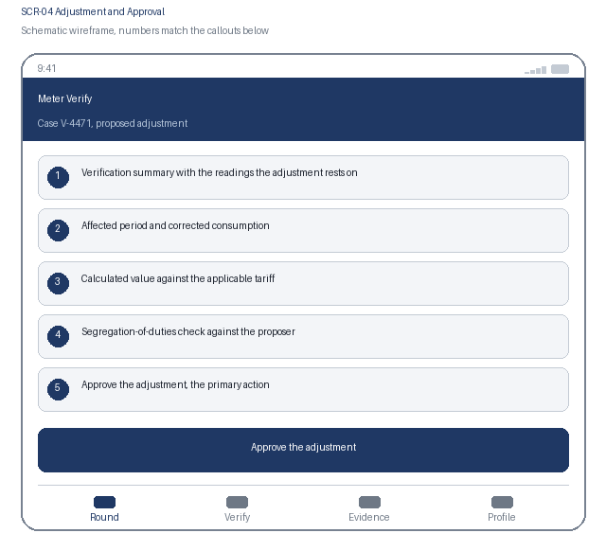  1. Verification summary with the readings the adjustment rests on  2. Affected period and corrected consumption  3. Calculated value against the applicable tariff  4. Segregation-of-duties check against the proposer  5. Approve the adjustment, the primary action | Specification panel  Purpose: The analyst proposes an adjustment calculated from the verification, and a second person approves it before it reaches the customer's bill.  Primary action: Approve the adjustment, which writes the immutable record and posts to billing exactly once.  Data: Verification readings, affected period, corrected consumption, tariff applied, calculated value, proposer and approver identity, segregation result, posting reference. Source: adjustment calculator and billing.  States: Proposed, blocked by segregation of duties, approved, posting in progress, posted, posting failed and queued, rejected  Roles: Analyst proposes; a different manager approves; auditor reads the posted record  Requirements: US-401, US-402, NFR-004, NFR-006, NFR-007

3.8 SCR-04 Interaction Details
Element / callout | Behavior | Validation | Accessibility
1. Calculation breakdown | Expands to show each reading, the period and the tariff applied | No figure is editable here; a wrong input requires the proposal to be reopened and recalculated | The breakdown reads as a table with row and column headers, and totals are announced
2. Segregation check | Evaluated server side when the approval screen opens | If the approver proposed the adjustment, approval is blocked and alternatives are offered | The block explains why in plain language rather than as a permission error
3. Reject action | Returns the proposal to the analyst with a mandatory comment | Comment mandatory, minimum 20 characters | Focus moves to the comment field with the requirement announced before entry
4. Approve the adjustment | Writes the record and posts to billing | If posting fails, the adjustment holds as approved and not posted, and the replay state is shown rather than a generic error | Confirmation states plainly that an approved adjustment affects a customer bill and cannot be undone

4. Navigation Flow
From | User action / condition | To | Alternate or error path
SCR-01 | Technician starts a verification job | SCR-02 | Appointment required and not booked, or a hazard unacknowledged: the job cannot start and the reason is stated
SCR-02 | Verification submitted with a broken or missing seal | SCR-03 | Seals intact with a reading discrepancy: skip to SCR-04 for an adjustment proposal
SCR-03 | Tamper case submitted with complete evidence | SCR-04 | Evidence or custody incomplete: submission is blocked and the missing items are named
SCR-04 | A second approver approves and the adjustment posts | SCR-01, with the case closed | Segregation of duties blocks approval, or posting fails and the adjustment holds as approved and not posted
Flow: SCR-01 Verification Round, start a job, to SCR-02 Guided Meter Verification, submit, to SCR-03 Tamper Evidence and Custody where tampering is suspected, to SCR-04 Adjustment and Approval for the revenue analyst, and back to SCR-01 for the next job. A clean verification with a reading discrepancy goes from SCR-02 straight to SCR-04, and the bottom tab bar reaches Round, Verify, Evidence and Profile.

5. Responsive Behavior
Viewport | Navigation | Layout | Content priority | Interaction changes
Phone | Bottom tab bar with four primary destinations | Single column, cards stacked in priority order | Access notes and hazards first, then the current verification step | One-handed reach in a meter cupboard with capture actions in the lower third; no swipe-only path
Tablet | Adaptive left navigation rail | Round list beside the selected job's verification detail | Primary list beside the selected item's detail panel | Touch and pointer both supported; hover reveals nothing essential
Web | Persistent left navigation with breadcrumbs | Case queue, verification detail and evidence gallery in three columns | Dense scanning of many records, with full detail on selection | Full keyboard support with shortcuts for approve and reject; no hover-only affordance

6. States and Content
State | Trigger | Displayed content | Available actions
Loading | A data request is still in flight after 300 ms | Skeleton content preserving the final layout, with capture enabled as soon as the meter is confirmed | Cancel and retry remain available
Empty | A filter, search or assignment returns no records | A plain statement that no jobs match, naming the active filter | Clear the filter, or switch to All jobs
Error | A request fails, times out, or is rejected by policy | What failed and whether the captured evidence was kept, which is stated first | Retry, with evidence always preserved locally
Offline | The device loses network connectivity | A persistent offline banner and a count of verifications and photographs waiting to sync | Capture continues; submission and approval queue and confirm after sync

7. Accessibility Requirements
- WCAG 2.2 AA is the conformance target for every screen, including all interactive states and error messaging.
- Every control is reachable in a logical tab order with a visible focus indicator, a programmatic label, and instructions announced before the input rather than only after an error.
- Errors are announced through an assertive live region, name the field, and describe how to correct the problem.
- Text contrast is at least 4.5 to 1 and non-text indicators at least 3 to 1; the interface remains usable at 200 percent text resize and at 320 CSS pixels wide.
- Motion is limited and honours the reduced-motion preference; no information is conveyed by colour alone.
- Touch targets are at least 44 by 44 CSS pixels with adequate spacing, so the interface stays usable with gloves or one hand.
- {Keyboard order, visible focus, labels, instructions, and error announcement behavior}
- {Contrast, text resize, reduced motion, screen-reader, and touch-target expectations}

8. Review and Approval
Reviewer | Role | Decision | Comments | Date
Design lead | UX design authority | Pending | Interaction model and visual specification
Accessibility specialist | Accessibility | Pending | WCAG 2.2 AA conformance evidence
Product owner | Business product owner | Pending | Screen inventory and flow confirmation

